STUDENT REGISTRATION FORM

NAME _____________________________________________________ AGE __________
ADDRESS ______________________________________________________________________
____________________________________________________________________
HOME PHONE _________________ CELL ________________
E-MAIL__________________________________________________
PARENT(S) NAMES ______________________________________________________________
PARENT(S) WORK NUMBER________________________________________________________
IN CASE OF EMERGENCY CONTACT ___________________________________ TEL:_______________________
ALLERGIES OR OTHER MEDICAL CONDITIONS
________________________________________________________________________________
FAMILY DOCTOR ___________________________________
TEL: ____________________________
VBS ATTENDNCE REGISTER

Teacher: _________________________________ Class: _________________

NAME | DAY 1 | DAY 2 | DAY 3 | DAY 4 | DAY 5 | TEAM

WORSHIP
TEXT OF THE DAY: 1 Chronicles 16:23-24
“Sing to the Lord, all the earth; proclaim his salvation day after day. Declare his glory among the nations, is marvellous deeds among all peoples.”

9:00 – 9:15 a.m. Welcome and Registration

9:15 – 10:00 a.m. Devotions ETS - Engaging the Scriptures
- (Use story format or suitable props)
- (discussion of scripture with application to life)
- Prayer

- SING-A-LONG: Song suggestions:
- I Pledge to Follow You & Hymn
      - God is so Good
      - Jesus loves me this I know

10:15 – 10:30 a.m. BREAK

10:30 – 11:00 a.m. EXTENDED ACTIVITY: CONVERSATIO N Invite children to speak frankly about their likes and dislikes about the way we currently worship (in church) create a psalm to express their appreciation of God. Allow them to say what they would prefer, how things could be different and use the opportunity to explain the way of Anglican worship

Invite a priest or church worker to host this conversation, if teacher does not feel competent in the area.

11:00 – 11:30 a.m. WORSHIP with ART & CRAFT:
Have children share their preferred type of worship style and allow them to create a liturgy to be used for their class.

11:30 – 12:00 p.m. DRAMA: Worship is our Work
Invite children to lead a ‘mock-up’ service as they drafted it. Ask them to offer some explanation.

12:00 p.m. –1:00 p.m. LUNCH
1:00 – 1:30 p.m. Dance and Movement
1:30 – 1:45 p.m. Review Game: Bucket of Gold
1:45 - 2:00 p.m. Closing devotion, Prayer Circle and Dismissal

RESOURCES: A CD player to play the different pieces of music
Crayons
Pencils to do Psalm

READING FOR THE DAY:
Acts 1:8
But you will receive power when the Holy Spirit has come upon you; and you will be my witnesses in Jerusalem, in all Judea and Samaria, and to the ends of the earth.”
WITNESS

9:00 – 9:30 a.m. Welcome and Registration

9:15 – 10:00 a.m. Devotions
- ETS - Engaging the Scriptures
- Reading of the Scripture (Use story format or suitable props)
- (discussion of scripture reading and application to life)
- Prayer

  - SING-A-LONG: Song suggestions:
  - I will make you fishers of men
  - I Pledge to Follow You & Hymn: Train Up the Child
  - Stop and let me tell you what the Lord has done for me – Marvia Providence

10:15 – 10:30 a.m. BREAK

10:30 – 11:00 a.m. WORSHIP with ART & CRAFT
EYEWITNESS VIDEO: Use a smartphone to make a video. Have the children give a description of some event they have seen. Encourage the children to give as many details of the event as possible. After they have finished this project, have the children to tell something they know about JESUS and to share as many details about what they have "witnessed" about JESUS in their lives. (He loves us; He takes care of us; He heals us; He protects us, etc.)

11:00 – 11:15 a.m. EXTENDED ACTIVITY: WRITE A PSALM / POEM / PRAYE Create a psalm to appreciate God: Study or present selected psalms and then help children write their own song of praise to God.
(Then have these psalms read by the child or an adult during the bucket of gold as closing activity.

11:30 – 12:00 p.m. DRAMA: Skit
Allow Children to create a play or skit in two groups displaying persons giving thanks and praise. Allow them to practice and perform that skit and allow the children to say something on the message they are trying to get across. Have a discussion about today's lesson and talk about simple ways we can and are able to witness to others about what Jesus means to us

12:00 p.m. –1:00 p.m. LUNCH

1:00 – 1:30 p.m. Dance and Movement
1:30 – 1:45 p.m. Review Game: Bucket of Gold

1:45 - 2:00 p.m. Closing devotion, Prayer Circle and Dismissal

RESOURCES: A CD Player to play the different pieces of music
Crayons
Pencils to do Psalm
Copies of Song sheets
Smart Phones or Tablets to capture video and to share

WORK
READING FOR THE DAY:
Colossians 3:23-24
Whatever you do, work at it with all your heart, as working for the Lord, not for human masters, since you know that you will receive an inheritance from the Lord as a reward. It is the Lord Christ you are serving.

9:00 – 9:30 a.m. Welcome and Registration

9:15 – 10:00 a.m. Devotions
- ETS - Engaging the Scriptures
- Reading of the Scripture (Use story format or suitable props)
- Discussion of scripture reading and application to life)
- Prayer

- SING-A-LONG: Song suggestions:
- Theme Song & VBS Hymn
- I am wrap up tied up in Jesus

10:15 – 10:30 a.m. BREAK
10:30 – 11:00 a.m. EXTENDED ACTIVITY: Create a Whatsapp or social media chat with messages going and coming about the work of God and how you can carry out God’s work. Use blank papers/cartridge paper and markers

11:00 – 11:15 a.m. ART and CRAFT:
Create a dance of praise that will show that you are doing God’s work
Colour the picture of dance in Art (attached)

11:30 – 12:00 p.m. DRAMA:
Use your various talents God has blessed you with to illustrate how you can carry out Gods work.

12:00 p.m. –1:00 p.m. LUNCH
1:00 – 1:30 p.m. Dance and Movement
1:30 – 1:45 p.m. Review Game: Bucket of Gold
1:45 - 2:00 p.m. Closing devotion, Prayer Circle and Dismissal

RESOURCES: A CD Player to play the different pieces of music
Crayons
Pencils to do Psalm

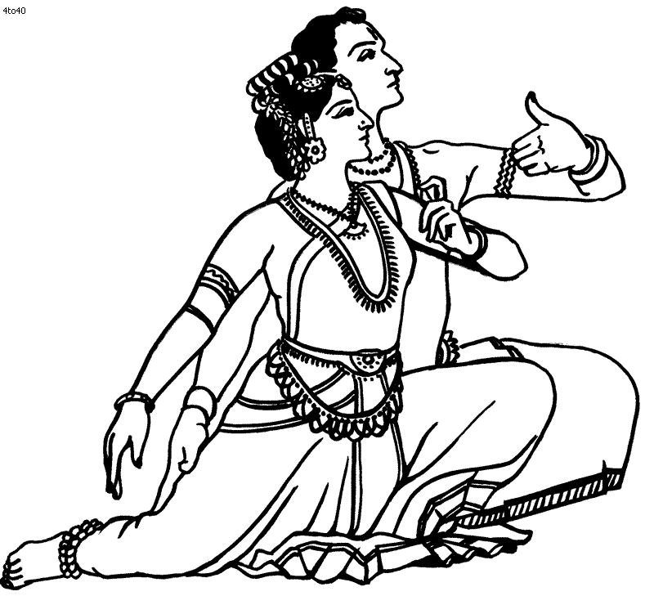

WELCOME
READING FOR THE DAY:
Hebrews 13:1-2:
Let mutual love continue. ²Do not neglect to show hospitality to strangers, for by doing that some have entertained angels without knowing it.

9:00 – 9:30 a.m. Welcome and Registration
9:15 – 10:00 a.m. Devotions
- ETS - Engaging the Scriptures
- Reading of the Scripture (Use story format or suitable props)
- Discussion of scripture reading and application to life)
- Prayer
- SING-A-LONG: Song suggestions:

    - Jesus loves me this I know
        - Smile a while
        - Stand up and tell me if you love my Jesus
        - Let us greet somebody in Jesus name
        - Jesus loves me this I know

10:15 – 10:30 a.m. BREAK

10:30 – 11:00 a.m. EXTENDED ACTIVITY: Create a dub poem about how you would treat a friend that in staying at your home for the weekend.
OR
As a group plan a skit that shows the different ways a person can show hospitality. The skit must have a direct message that everyone can understand.

11:00 – 11:15 a.m. OTHER ACTIVITY:
Complete the word puzzle on hospitality.

11:30 – 12:00 p.m. DRAMA:

12:00 p.m. –1:00 p.m. LUNCH
1:00 – 1:30 p.m. Dance and Movement
1:30 – 1:45 p.m. Review Game: Bucket of Gold

1:45 - 2:00 p.m. Closing devotion, Prayer Circle and Dismissal

RESOURCES: A CD player to play the different pieces of music
Crayons
Pencils to do Psalm

C | F | R | E | C | R | E | A | T | I | O | N | I | S | E | T | H | I | C | S
X | G | S | G | X | H | Q | V | L | S | A | N | I | T | A | T | I | O | N | E
B | H | N | R | E | P | O | S | I | T | I | V | E | E | H | F | C | Q | Z | L
R | E | O | E | N | F | J | S | T | B | J | G | W | Z | Q | O | E | R | U | I
A | S | I | E | T | Y | S | V | S | E | V | Y | W | K | M | A | T | T | O | M
N | I | T | T | H | Y | U | J | O | V | D | T | P | V | Q | E | C | E | Y | S
D | H | A | E | U | T | P | I | H | E | Y | I | C | E | J | M | E | S | L | P
P | C | T | R | S | E | P | M | L | R | P | L | H | Y | H | P | P | N | K | S
A | N | C | O | I | F | O | O | D | A | E | A | A | E | O | A | S | O | G | M
P | A | E | R | A | A | R | L | U | G | R | U | I | C | S | T | E | I | Y | W
P | R | P | E | S | S | T | A | I | E | S | Q | N | O | P | H | R | T | P | G
E | F | X | M | M | T | T | V | D | R | O | T | Z | N | I | Y | V | U | I | N
A | S | E | O | C | R | A | O | M | E | N | U | V | T | T | T | I | L | Y | P
R | D | T | T | X | A | N | R | U | C | A | T | R | A | A | N | C | O | T | R
A | E | B | S | F | V | Y | P | D | R | L | O | R | C | L | U | E | S | S | E
N | E | S | U | E | E | L | P | X | X | I | A | T | T | I | T | U | D | E | G
C | N | C | C | H | L | N | A | B | J | T | S | B | A | T | M | G | M | N | A
E | F | F | I | C | I | E | N | T | X | Y | U | M | F | Y | V | F | M | O | N
R | E | S | T | S | A | T | I | S | F | A | C | T | I | O | N | W | N | H | A
M | A | N | N | E | R | S | H | O | P | P | I | N | G | U | E | S | T | F | M

service | customer | food | beverage | Needs
empathy | personality | smile | eye contact | Enthusiasm
hospitality | quality | hotels | tip | Attitude
positive | appearance | efficient | guest | Satisfaction
expectations | ethics | honesty | chain | Franchise
host | travel | tourism | recreation | Safety
menu | safety | sanitation | support | Solutions

