What is Advent? Advent is the first season of the church and is a time when we prepare our hearts to receive Christ. Advent refers to the “coming” or “arrival” – in our case, the coming or arrival of Jesus Christ.
How long is Advent? Advent always includes four Sundays and ends with Christmas Eve. The season of Advent may include singing, reading scripture, praying, silent reflection and even a short devotional type reading.
Advent is a time of waiting? As Christians who want to grow in our relationship with Christ we spend time during Advent in a meaningful way in devotions and prayer to help us experience the presence of Christ in our heart. Advent also helps Christians to focus on Christ’s promised return to the world. In this way Advent is also a time of waiting,
What is the colour of Advent? The traditional colour for Advent is purple which is the colour for kings, but it also refers to repentance.
Advent Prayer:
Thank you O God, for giving us your most precious gift, Jesus Christ! We await his return and celebrate his love for us. Help us to share the Good News of Jesus with others and to follow Jesus in our actions for the rest of our lives! AMEN.
Week of Advent 1: PREPARE
Step 1: Create a circle and use an Advent Wreath or cross as the focus in the centre. Light one candle beside the cross or in the Advent Wreath.
Step 2: Sing Hymn/Song: “All for Jesus”
Step 3: Read Scripture: Isaiah 40:3-5
A voice cries: “In the wilderness prepare the way of the LORD, make straight in the desert a highway for our God. Every valley shall be lifted up, and every mountain and hill be made low; the uneven ground shall become level, and the rough places a plain. And the glory of the LORD shall be revealed, and all flesh shall see it together, for the mouth of the LORD has spoken.”
Step 4: TALK: Talk about a special Christmas from your past and what you are looking forward to this Christmas.
Step 5: Secret Angel: Write a short letter to a special friend or a person you wish to be friends with telling them one good thing you will do to during Advent.

Week of Advent 2: JOURNEY
Step 1: Set the Advent Wreath or cross as the focus in the centre. Light two candles beside the cross or in the Advent Wreath.
Step 2: Sing Hymn: “O Little Town of Bethlehem
Step 3: Read Scripture: Luke 2:1-7
At that time, Augustus Caesar sent an order to all people in the countries that were under Roman rule. The order said that they must list their names in a register. This was the first registration taken while Quirinius was governor of Syria. And everyone went to their own towns to be registered. So Joseph left Nazareth, a town in Galilee. He went to the town of Bethlehem in Judea. This town was known as the town of David. Joseph went there because he was from the family of David. Joseph registered with Mary because she was engaged to marry him. (Mary was now pregnant.) While Joseph and Mary were in Bethlehem, the time came for her to have the baby. She gave birth to her first son. There were no rooms left in the inn. So she wrapped the baby with cloths and laid him in a box where animals are fed.
Step 4: TALK: Talk about what is fun or what is difficult about your daily trips?
Step 5: Secret Angel: Make a special ornament to take to someone in the community who lives alone.

Week of Advent 3: WATCH
Step 1: Set the Advent Wreath or cross as the focus in the centre. Light three candles around the cross or in the Advent Wreath.
Step 2: Sing Hymn: “O Come, O come Emmanuel”
Step 3: Read Scripture: Luke 2:8-10
And in that region there were shepherds out in the field, keeping watch over their flock by night. And an angel of the Lord appeared to them, and the glory of the Lord shone around them, and they were filled with fear. And the angel said to them, "Be not afraid; for behold, I bring you good news of great joy which will come to all the people.”
Step 4: TALK: Talk about the gifts you give to others and the joy it brings you when they are happy about your gift. Talk about what gift you will bring to Jesus.
Step 5: Secret Angel: From cardboard make and use old Christmas cards to decorate a placemat or make a gift card to give to someone who you intend to invite to your Christmas Day Service.

Week of Advent 4: ANGELS
Step 1: Set the Advent Wreath or cross as the focus in the centre. Light four candles around the cross or in the Advent Wreath.
Step 2: Sing Hymn: “Joy to the World”
Step 3: Read Scripture: Luke 2:15-20 When the angels went away from them into heaven, the shepherds said to one another, “Let us go over to Bethlehem and see this thing that has happened, which the Lord has made known to us.” And they went with haste, and found Mary and Joseph, and the babe lying in a manger. And when they saw it they made known the saying which had been told them concerning this child; and all who heard it wondered at what the shepherds told them. But Mary kept all these things, pondering them in her heart. And the shepherds returned, glorifying and praising God for all they had heard and seen, as it had been told them.
Step 4: TALK Jesus has many names: Wonderful Counselor, Mighty God, Everlasting Father, Prince of Peace, Messiah, the Lamb of God, Emmanuel (God with us). What does our name mean? How does your name reveal your purpose?
Step 5: Secret Angel: Reveal yourself as the Secret Angel to the person who has received all your gifts over the weeks of Advent and invite them to join you in your Christmas Day Service.
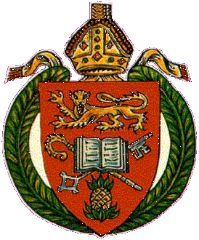
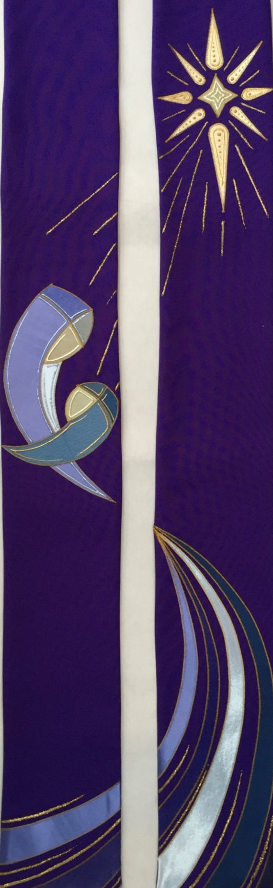
LEARNING TOGETHER SERIES

Journey through
Advent

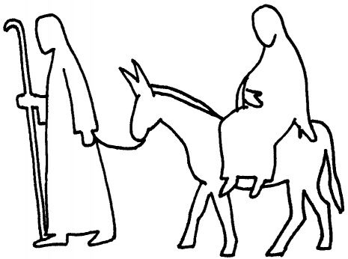

At Christmas we celebrate the birth of Jesus Christ. Can you name some of the major characters who were part of this Nativity story?
- _________________________
- _________________________
- _________________________
- _________________________
- _________________________
We can be like Mary and Joseph by doing what God wants us to do, such as: ____________. ANS: (Be obedient)
We can be like the shepherds and Wise Men by following Jesus Christ, and doing what: _____. ANS:(Bringing our gifts to him and worship him)

How can we follow the example of the angels in the story of Christmas. ANS:(By telling others about Jesus the saviour who was born to save us from our sins)
Jesus is the real gift of Christmas. So as we share gifts this Christmas let us remember that what we share should be something that help others to experience the love of God who came to us in Christ Jesus.
Sing:
Joy to the world, the Lord has come!
Let earth receive her King
Let every heart prepare Him room
And Heaven and nature sing
And Heaven and nature sing
And Heaven, and Heaven, and nature sing

Joy to the World, the Saviour reigns!
Let men their songs employ
While fields and floods, rocks, hills and plains
Repeat the sounding joy
Repeat the sounding joy
Repeat, repeat, the sounding joy

No more let sins and sorrows grow
Nor thorns infest the ground
He comes to make His blessings flow
Far as the curse is found
Far as the curse is found
Far as, far as, the curse is found

He rules the world with truth and grace
And makes the nations prove
The glories of His righteousness
And wonders of His love
And wonders of His love
And wonders, wonders, of His love

Division of Christian Education Diocese of Jamaica & the Cayman Islands 2 Caledonia Avenue Kingston 5 / Tel: 876-926-8926 / youth@anglicandiocese.com

LEARNING TOGETHER SERIES
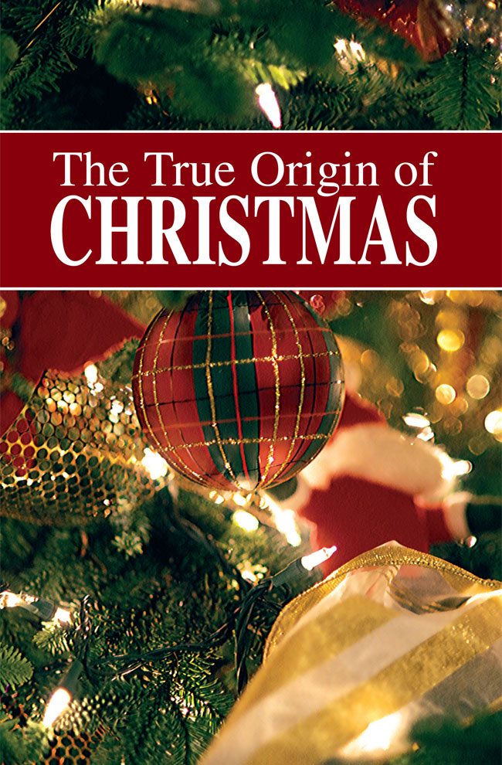


Sing:
O come, O come, Emmanuel And ransom captive Israel That mourns in lonely exile here Until the Son of God appear Rejoice, rejoice, Emmanuel Shall come to thee, O Israel
A long time ago, a woman named Mary and a man named Joseph were going to be married. Mary and Joseph were good people who did what God wanted them to do. One day an angel came to Mary and told her she was going to have a baby! The angel said she should name the baby Jesus. The baby would be the Son of God, the Saviour.
Mary and Joseph had to travel to a town called Bethlehem to pay taxes. The town was so crowded that Mary and Joseph had to find a place to sleep. They could not find anywhere to spend the night so they had to settle for a corner in a place where animals were kept – a stable. That same night baby Jesus was born!
Sing:
Away in a manger, No crib for His bed The little Lord Jesus laid down His sweet head
At Jesus’ birth a bright new star appeared in the sky. Shepherds who were taking care of sheep in nearby fields saw the star and were excited. They wondered what this star meant.
Sing:
Shepherds in the field abiding,
tell us, when the seraph bright
greeted you with wondrous tiding
what you saw and heard that night.
Gloria in excelsis Deo.

While the Shepherds wondered about this great star, a host of Angels appeared and told the shepherds that Jesus the Saviour had been born. But where was he born? Who can tell? __________. The shepherds were really frightened but after the angels went away, the shepherds went to find the place where Jesus was born. When they got there they knelt down and worshipped the baby Jesus.

Sing:
Angels from the realms of glory,
Wing your flight o'er all the earth;
Ye who sang creation's story,
Now proclaim Messiah's birth:
Come and worship,
Come and worship,
Worship Christ, the new-born King!

Far away, Wise Men saw the new star. They knew it was a sign that the Saviour had been born. They decided to follow the star until they found Jesus. They had brought with them gifts of Gold, Frankincense and Myrrh. They, like the Shepherds, knelt and worshipped the baby king and gave Him presents they brought.
Sing:
We three kings of Orient are
Bearing gifts we traverse afar
Field and fountain, moor and mountain
Following yonder star
O Star of wonder, star of night
Star with royal beauty bright
Westward leading, still proceeding
Guide us to thy Perfect Light

After the Wise Men left, an angel visited Joseph. The angel to him that a bad king (King Herod) wanted to hurt the baby Jesus. The angel told Joseph that he should take the family and move to Egypt to be safe.
Sing:
Once in royal David’s city,
Stood a lowly cattle shed,
Where a mother laid her Baby,
In a manger for His bed:
Mary was that mother mild,
Jesus Christ, her little Child.

So Joseph, Mary, and baby Jesus lived in Egypt until it was safe to return to Israel. Jesus grew up in a town called Nazareth. He learned to be helpful, kind, and obedient. He learned everything that He needed to learn to be our Saviour. He always followed God’s plan for Him.
STUDY 3
TOPIC: The Prophesy
TEXT: Luke 1:67-79
Start with Prayer Comment: We have this GREAT story of how Zechariah and Elizabeth were blessed with the birth of John, both John and Zechariah was filled with the Holy Spirit. Now Zechariah is proclaiming the wonder of what God has done and will do in his song.
Read: Luke 1:67-75 and answer these questions:
- When Zechariah was filled with Holy Spirit, what did he do?
- Read together (or out loud) Luke 1:67-79
- What is the salvation that Zechariah refers to?
- What did God do and what were the people now able to do?
CONVERSATION:
- We’ve mentioned this before but what is the enemy that God has rescued us from?
- In what ways are we able to serve God in the same way as Zechariah outlines here?
- At home, or at work this week, how can we serve God in the way that Zechariah suggests in his song?

Family Prayer Requests:
Pray: Heavenly Father, thank-you for the Holy Spirit that is still alive and well in all believers today. Help us to be in tune with the Holy Spirit that we will willingly follow the way of his guidance in our lives. In Jesus’ Name we pray. Amen.
Division of Christian Education / Diocese of Jamaica & the Cayman Islands 2 Caledonia Avenue Kingston 5 / Tel: 876-926-8926 / youth@anglicandiocese.com

STUDY 4
TOPIC: The Prophesy part 2
TEXT: Luke 1:67-80
Start with Prayer Comment: Zechariah first talks about Jesus and salvation, and how God has saved the people of Israel from their enemies in the past but now he goes on to talk about his son, John and what his role in all of this.
Read: Luke 1:76-80 and answer these questions:
1. Why will the baby be called John? 2. How will the people have knowledge of salvation? 3. Who is Zechariah referring to in the rising sun?
CONVERSATION:
- Why do you think that John grew up in the desert?
- John’s name revealed his purpose. What is your name? What does your name mean? Does your name suggest what God intends your life’s purpose to be?
- Do you have children? What names have you given your children? Why?
- Did you pray about those names and are your children living the meaning of their names?

Family Prayer Requests:
Pray: Heavenly Father, we do not have easy lives. Strengthen us by our wilderness experiences. As we become stronger give us purpose as we help others to fulfil their purpose. In Jesus’ Name we pray. Amen.

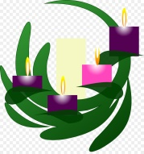

LEARNING TOGETHER SERIES

On
SPOT
On
SPOT

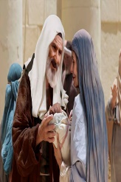

“Discipling Men through Biblical Conversation”
GUIDE VERSE:
“Give thanks to the Lord for his unfailing love and his wonderful deeds for men” - Psalm 107:15

INTRODUCTION
As far as history can recall to our present time God has been choosing to break into the lives of “ordinary people” to bring God’s plan of salvation into reality. In the story we are about to study God chose to give a son to two people Elizabeth and Zechariah. Both persons were old and Elizabeth was barren up until this point of her life. When God sent a message to Zechariah that he and his wife would have a son, he didn’t believe it, and for this lack of faith, God made him dumb until the promised son (John) was born. Elizabeth was happy for the child and ready for God’s will to be done in her life. The child, John the Baptist’s sole purpose was to go before the Lord to prepare His way, to Baptize Him and proclaim Him the Lamb of God who would take away the sin of the world. Using this family as an example we can see ourselves as part of God’s plan of salvation. Each of us plays a role in the unfolding of God’s love although at times we get caught up in our demands or pursuits and cannot see the meaningful roles we have to play in God’s plan of salvation for us and others. As we explore the way in which God broke into the life and reality of the couple, Zechariah and Elizabeth, each of us is invited to ask this question: “How open am I to the will of God, especially when it interrupts my own plans and expectations?” God’s plan sometimes involves breaking us out of our ‘neatly planned lives. In this 4 part series, let us learn about this man, Zechariah, the Priest who became a father in his old age.
- This is a 4 part study for each week in Advent. As we look forward to Christmas, we invite and encourage men to gather in conversation each week.
- Studies may be led anywhere - in an adult forum or BSA meeting, in a cottage meeting or even on the roadside under a street light
- Each study should take 45 minutes to 1 hour.
STUDY 1
TOPIC: Who is Zechariah
TEXT: Luke 1:5-25 & 67-79
Start with Prayer Comment: We have two stories running together here. The first is the birth of John the Baptist as foretold in the first part of Luke chapter 1, and then right after it is the birth of Jesus foretold.
Read: Luke 1:5-25 and answer these questions:
- What is Zechariah’s job?
- What is the description of what John the son will be like?
- Zechariah questioned the angel, what were Zechariah’s concerns?
- What happened to Zechariah because he questioned the angel?

CONVERSATION:
- What happened to Zechariah when he didn’t believe the angel?
- What was Gabriel’s explanation of Zechariah’s dilemma?
- What was Zechariah’s total dilemma?
- What is your personal dilemma?
- As a father and or male role model, how do you see Zechariah’s obedience as an example to follow as you deliberately seek to journey with another young man?

Family Prayer Requests:
Pray: Heavenly Father, we often question why or how situations in our life happen, help us to put our full trust in you and in your ability to know and do what is best for us. In Jesus’ Name we pray. Amen.
STUDY 2
TOPIC: Zechariah’s Song
TEXT: Luke 1: 57-79
Start with Prayer Comment: Last week we talked about how Zechariah had doubts about the possibility of Elizabeth being able to have a baby. He doubted God and was kept from speaking until the after John the Baptist was born, He was only allowed to speak on the day when they were circumcising John as we see in today’s scripture.
Read: Luke 1:57-66 and answer these questions:
- Why did everyone question the name ‘John’?
- How was the “Lord’s hand” with John? (Luke 1:15)
- At what moment was Zechariah able to speak?
- What did Zechariah start doing right away?

CONVERSATION:
- What could have happened if Zechariah spoke before the baby was circumcised?
- As a male in your family, at work or community what happens when you refuse to speak?
- When is it a good thing to stay silent?
- What are some things that hinder you from holding your peace (or following the will of God?)

Family Prayer Requests:
Pray: Heavenly Father, as we begin to know you more and more loosen our tongues to speak of your love and mercy, but teach us to hold our peace and allow your will to be done in our lives as we praise your name. In Jesus’ Name we pray. Amen.

King Herod Joseph Mary Baby Jesus The Wise Men The Shepherds Angels
B E T H L E H E M (of JUDEA)

