STUDENT REGISTRATION FORM

NAME _____________________________________________________ AGE __________
ADDRESS _____________________________________________________________________
_____________________________________________________________________
HOME PHONE _________________ CELL ________________ E-MAIL_________________________
PARENT(S) NAMES __________________________________________________________________
PARENT(S) WORK NUMBER __________________________________________________________
IN CASE OF EMERGENCY CONTACT _________________________ TEL:___________________
ALLERGIES OR OTHER MEDICAL CONDITIONS ________________________________________
FAMILY DOCTOR ___________________________________ TEL: ___________________________
VBS ATTENDNCE REGISTER

Teacher: _________________________________ Class: _________________

NAME | DAY 1 | DAY 2 | DAY 3 | DAY 4 | DAY 5 | TEAM

WORSHIP

9:00 – 9:30 a.m. Welcome and Registration

9:15 – 10:00 a.m. Devotions
- ETS - Engaging the Scriptures
- Reading of the Scripture (Use story format or suitable props)
- (discussion of scripture reading and application to life)
- Introduction to Theme Song & VBS Hymn
      - Prayer

- SING-A-LONG: Song suggestions:
  - Intentional Discipleship Theme Song & VBS Hymn
TEXT OF THE DAY: 1 Chronicles 16:23-24
“Sing to the Lord, all the earth; proclaim his salvation day after day. Declare his glory among the nations, is marvelous deeds among all peoples.”

  - Jesus loves me this I know
  - God is so Good

10:15 – 10:30 a.m. BREAK

10:30 – 11:00 a.m. WORSHIP with ART & CRAFT:
Have children do Colouring page 1

11:00 – 11:15 a.m. DRAMA (script attached.)

11:30 – 12:00 p.m. Dance and Movement

12:00 p.m. –1:00 p.m. LUNCH

1:00 – 1:30 p.m. EXTENDED ACTIVITY: WRITE A PSALM
Create a psalm to appreciate God: Study or present selected psalms and then help children write their own song of praise to God. You can have a page of fill in the blank by having children state or write and complete the beginning of a praise line,

“I Praise God for _______________, when I see _________________ I know my God is real, in the morning I say to God __________________.

(Then have these psalms read by the child or an adult during the bucket of gold as closing activity.

1:30 – 1:45 p.m. Review Game: Bucket of Gold

1:45 - 2:00 p.m. Closing devotion, Prayer Circle and Dismissal

RESOURCES: A CD Player to play the different pieces of music
Crayons, pens, pencils to do Psalm
DRAMA:

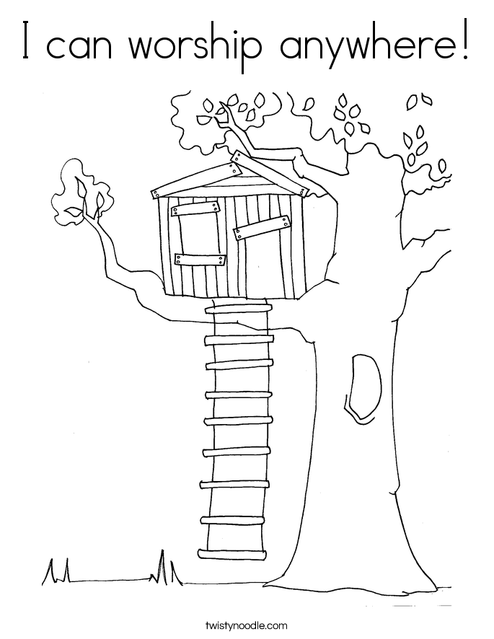
Colouring Page 1

Colouring Page 2

WITNESS
Acts 1:8
But you will receive power when the Holy Spirit has come upon you; and you will be my witnesses in Jerusalem, in all Judea and Samaria, and to the ends of the earth.”

9:00 – 9:30 a.m. Welcome and Registration

9:30 – 10:00 a.m. Devotions
      - ETS - Engaging the Scriptures
  - Reading of the Scripture (Use story format or suitable props)
  - (discussion of scripture reading and application to life)
  - Introduction to Theme Song & VBS Hymn
  - Prayer

- SING-A-LONG: Song suggestions:
- I will make you fishers of men
- I Pledge to Follow You & Hymn: Train Up the Child
- Stop and let me tell you what the Lord has done for me – Marvia Providence

10:15 – 10:30 a.m. BREAK

10:30 – 11:00 a.m. EXTENDED ACTIVITY:
Create a poem or song about the many miracles God has done for you and your family or friends
OR
Draw a picture of yourself receiving miracles and blessing from God, and below write two sentences describing how those miracles make you to feel.

11:00 – 11:15 a.m. WORSHIP with ART & CRAFT: CLOUD AND DOVE ART:
Allow the children to draw a cloud and add tufts of cotton and pictures or stickers of doves. Write “I saw the Spirit come down from heaven as a dove and remain on him.” John 1:32 on the cloud or around the edges of the poster.

11:30 – 12:00 p.m. DRAMA:

12:00 p.m. –1:00 p.m. LUNCH
1:00 – 1:30 p.m. Dance and Movement
1:30 – 1:45 p.m. Review Game: Bucket of Gold

1:45 - 2:00 p.m. Closing devotion, Prayer Circle and Dismissal

RESOURCES: A CD player to play the different pieces of music
Crayons
Pencils to do Psalm
Copies of Song sheets


READING FOR THE DAY:
Colossians 3:23-24
Whatever you do, work at it with all your heart, as working for the Lord, not for human masters, since you know that you will receive an inheritance from the Lord as a reward. It is the Lord Christ you are serving.

9:00 – 9:30 a.m. Welcome and Registration

9:15 – 10:00 a.m. Devotions
- ETS - Engaging the Scriptures
- Reading of the Scripture (Use story format or suitable props)
- (discussion of scripture reading and application to life)
- Theme Song & VBS Hymn
- Prayer

- SING-A-LONG: Song suggestions:
- Theme Song & VBS Hymn
- I am wrap up tied up in Jesus
- I am on the battlefield for my Lord

10:15 – 10:30 a.m. BREAK

10:30 – 11:00 a.m. DRAMA:
(Please see attached story: Special Work)

11:00 – 11:30 a.m. EXTENDED ACTIVITY: Invite children to share with each other how they are doing God’s work.
THEN
Colour picture: Finding Jesus in the maze
OR
Special Work Riddle

11:30 – 12:00 p.m. Dance and Movement
Create a dance of praise that will show that you are doing God’s work

12:00 p.m. –1:00 p.m. LUNCH

1:00 – 1:30 p.m. ART AND CRAFT
Create a Get Well card for someone who is in hospital

OR

Create a small invitation for someone you want to invite to come to church
1:30 – 1:45 p.m. Review Game: Bucket of Gold

1:45 - 2:00 p.m. Closing devotion, Prayer Circle and Dismissal

RESOURCES: A CD Player to play the different pieces of music
Crayons
Copies of colouring page
Cartridge paper, markers and scissors create card or invitation

SPECIAL WORK:
- Give each child some paper and crayons. Ask them to draw a picture of themselves.
- Let each child show their portrait, introduce themselves, and say something that they are good at. (“Hi, My name is ________. One thing that I am good at is (helping mommy, riding a bike, setting the table, picking up toys, etc.)” Tell children that God made us all special, different from one another and with different talents and abilities. This makes life very interesting. The Bible tells us this.
- Ask everyone to stand and do the following: Raise your Hands, Stomp your feet, Clap your hands, touch your toes. ( Tell the class that you are pretending to be one body and that everyone has to do the motions at the same time.)
- Ask Children, why they think God made everyone good at different things? (Allow for answers) God gave us one church with many members and everyone has a different job. When we work together we get more done and we help more people know about God. If you are good at teaching then you should be a teacher. If you are good at singing then maybe you should be in the choir. One person cannot do all the jobs in the church by themselves. Church members have to work together. Let’s play a game where you all have to work together. .
Happy Helpers
Read Colossians 3:23, “Whatever you do, work at it with all your heart, as working for the Lord, not for human masters.”
Before Class: Cover a small box with white paper to make a die. Write the following jobs on each side of the box: Preacher, Worship Leader, Teacher, Usher, Secretary, Caretaker.
Teacher Say: Raise your hand if you like to work: cleaning up your room, taking out the garbage, and helping others! The Bible verse we just read tells us that we should work like we are working for the Lord no matter what we do. That means we should always do our best. God likes happy helpers. It is important to be a happy helper at church as well. Remember, everyone who is a church member needs to also be a church helper. You have a place in the church and you can make a difference!
Game: to be a happy helper in the Church.
Roll the box and have individual students get up and explain what each job include (whichever job is on top of the box when it stops rolling. Let each child have a turn rolling the box.

Special Work Riddle
Today we learned that everyone is different and that God gave everyone different skills. We also learned that God wants us to happily use our skills to help the church. Let’s tell some riddles to help you remember what we learned today.
- If you can preach, then you should be a Preacher; but if you like to teach, then you should be a ____________. (Teacher)
- When it’s time to clean up I won’t whimper; because I can be a happy ___________. (Helper)
- When we work together its more fun, to get all of our work _____________. (Done)
- Everyone is good at different things; one person preaches while the other one ______. (Sings)
- God made me and He made you, and He gave us each a job to ___________. (Do)

Hebrews 13: 1-2:
Let mutual love continue. ² Do not neglect to show hospitality to strangers, for by doing that some have entertained angels without knowing it.
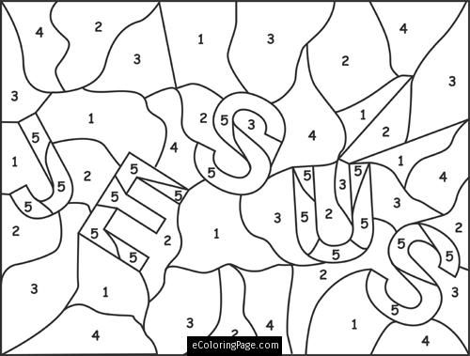
Find Jesus in the Maze
Colouring Page 1
When we work for God, it is important to know that Jesus is the best example of service. Jesus had to spend a lot of time in crowds, in conflicts with those who did not believe his teachings and at times he went away to the wilderness.
As followers of Jesus part of our work is to find Jesus in the middle of all the things that crowd our attention. Can you find Jesus in this maze?
Use crayons to colour the different spaces in the picture above to find Jesus in this maze.

WELCOME
READING FOR THE DAY:
Hebrews 13:1-2:
Let mutual love continue. ²Do not neglect to show hospitality to strangers, for by doing that some have entertained angels without knowing it.

9:00 – 9:30 a.m. Welcome and Registration
9:15 – 10:00 a.m. Devotions
- ETS - Engaging the Scriptures
- Reading of the Scripture (Use story format or suitable props)
    - (discussion of scripture reading and application to life)
    - Introduction to Theme Song & VBS Hymn
    - Prayer

- SING-A-LONG: Song suggestions:
    - Intentional Discipleship Theme Song & VBS Hymn
    - Jesus loves me this I know
    - Smile a while
    - Stand up and tell me if you love my Jesus
    - Let us greet somebody in Jesus name

10:15 – 10:30 a.m. BREAK

10:30 – 11:00 a.m. EXTENDED ACTIVITY: Create a song/poem about how you would treat a new student at your school.
OR
Colour pictures 4 & 5 of persons showing hospitality.

11:00 – 11:15 a.m. ART and CRAFT:
Complete the Maze that will lead you to the kingdom of God by colouring the path.

11:30 – 12:00 p.m. DRAMA:

12:00 p.m. –1:00 p.m. LUNCH
1:00 – 1:30 p.m. Dance and Movement
1:30 – 1:45 p.m. Review Game: Bucket of Gold

1:45 - 2:00 p.m. Closing devotion, Prayer Circle and Dismissal

RESOURCES: A CD player to play the different pieces of music
Crayons
Pencils to do Psalm

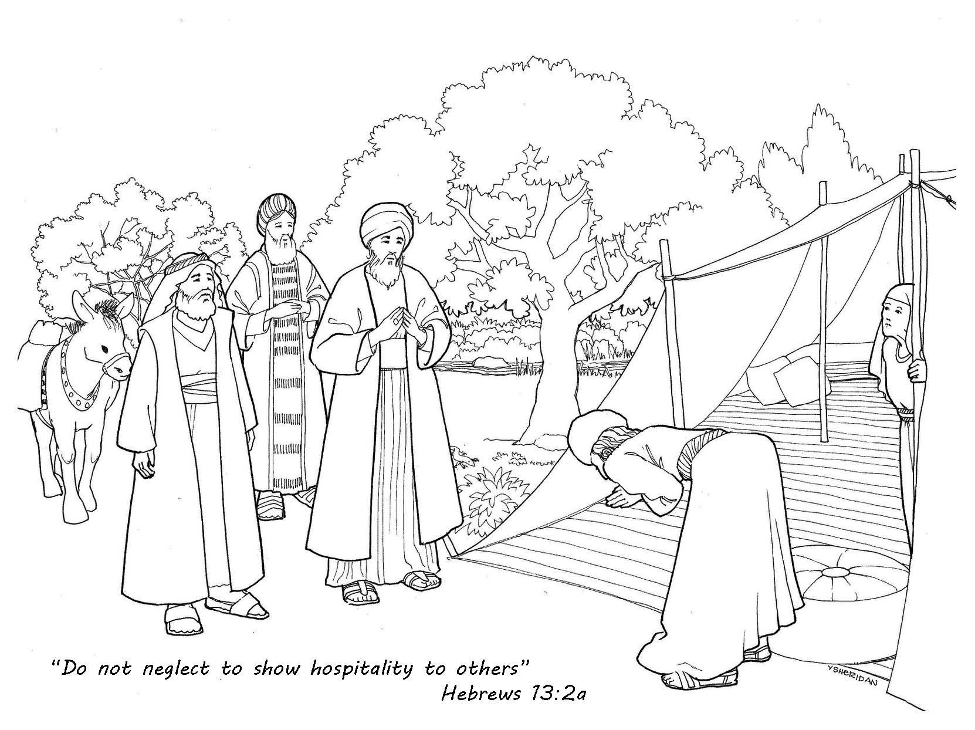
Colouring Page 1

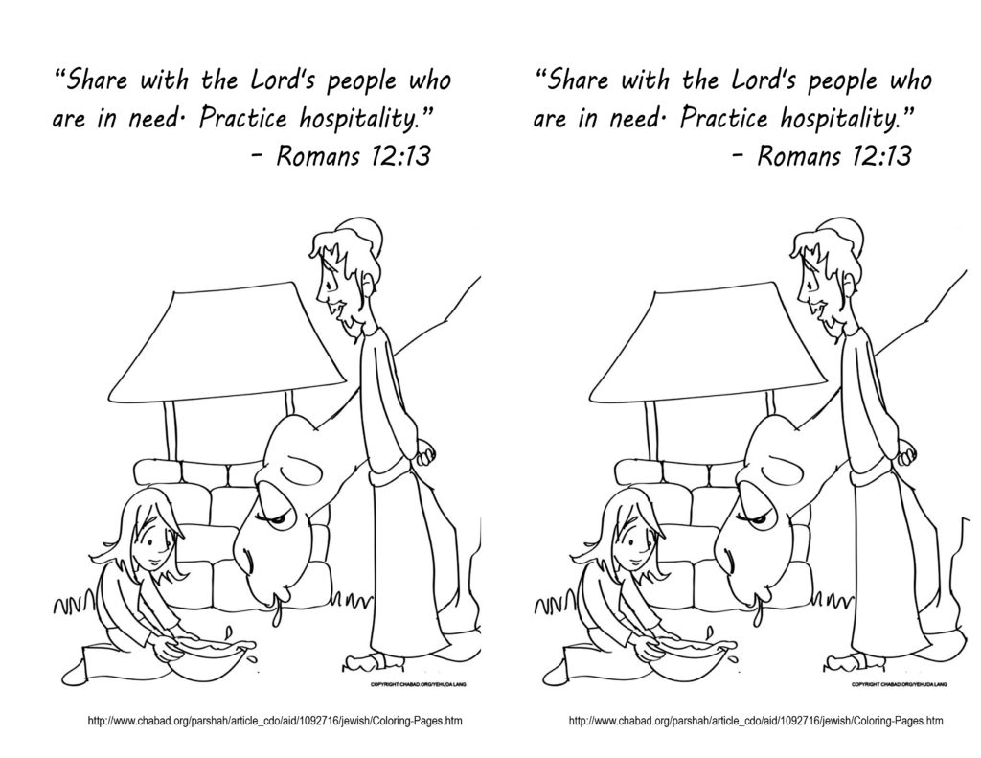
Colouring Page 2
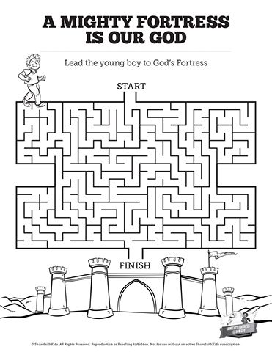

Person 1: Is anyone going to be in heaven because of you? Person 2: I have achieved so much already in my life. When I was at school I captained the school cricket team, the school football team and was lead violinist in the school orchestra. I honestly don’t know how I had the time to get my fourteen CSEC Subjects – all A* grades and five A levels – again all A* grades. I then went onto Cambridge University where I got a first class honours degree in Mathematics. Person 1: Is anyone going to be in heaven because of you? SILENCE Person 3: I hope that my life has brought glory to God. When I was at school I never did very well at any particular subject although I tried really hard. I made friends with a boy no-one else liked and took him to my Sunday school group one week. He really liked it there and came every week with me. It was amazing how much he changed. Person 1: Is anyone going to be in heaven because of you? (Someone offstage responds – “I am!” Person 2: I left University and went to work for a multinational oil company where I just seemed to receive promotion after promotion. Everything I touched went well and I am now one of the Directors. Person 1: Is anyone going to be in heaven because of you? SILENCE Person 3: After school I got a job as an apprentice to a local carpenter where I worked hard and just about made a living. One day in church, I heard about the terrible lives of the street children in Brazil. Our Vicar encouraged us to sponsor a child, so that they could get the food and clothes that they needed and also hear about Jesus and His love for them. I sponsored a little girl. Person 1: Is anyone going to be in heaven because of you? (Someone offstage responds – “I am!” Person 2: Of course it wasn’t long before the money was rolling in, and I have enjoyed my fair share of cars, and holidays and women. Mind you I have had to work hard; keeping at the top isn’t easy. And then along came Susan, the most beautiful woman I have ever seen and naturally I asked her to marry me. How could she resist me? I had everything a woman wants; cars, money, status and looks. Person 1: Is anyone going to be in heaven because of you? SILENCE Person 3: After work each Wednesday night I go out to the roughest parts of the city with a dozen other Christians and we give out soup and cakes to the homeless people there. It has been amazing the conversations I have had with people. One day I had the chance to tell a very old man who lived on the streets all about Jesus and then pray with him. After I had prayed for him his face was shining. Person 1: Is anyone going to be in heaven because of you? (Someone offstage responds – “I am!” Person 2: I have three wonderful children, who are all hugely talented and a great credit to my parenting skills. I don’t see much of them though as my hobbies of water-skiing, rock climbing and scuba diving take me away from home most weekends. Yes I would say my life has been a good one. I expect God will be most impressed with all I have achieved when I reach the pearly gates. Naturally I have put in regular appearances at church to keep my heavenly seat warm so to speak. Person 1: Is anyone going to be in heaven because of you? SILENCE Person 3: Sometimes I look at other people and they seem to have achieved so much with their lives. My priority has been to get to know and love Jesus and to love other people. I pray most days for my sister who doesn’t yet know Jesus, and I try to do small things to show my friends and neighbours God’s love but I don’t know whether this has had any effect on them. Overall I have lived a pretty ordinary life. Person 1: Is anyone going to be in heaven because of you? (Someone offstage responds – “I Will!” Person 1: St. Paul said in Acts 20:24 “But life is worth nothing unless I use it for doing the work assigned me by the Lord Jesus—the work of telling others the Good News about God’s mighty kindness and love.” Is anyone going to be in heaven because of you?

