STUDENT REGISTRATION FORM

NAME _____________________________________________________ AGE __________
ADDRESS _____________________________________________________________________
_____________________________________________________________________
HOME PHONE _________________ CELL ________________ E-MAIL_________________________
PARENT(S) NAMES __________________________________________________________________
PARENT(S) WORK NUMBER ___________________________________________________________
IN CASE OF EMERGENCY CONTACT __________________________ TEL:___________________
ALLERGIES OR OTHER MEDICAL CONDITIONS _________________________________________
FAMILY DOCTOR ___________________________________
TEL: ____________________________
VBS ATTENDNCE REGISTER

Teacher: _________________________________ Class: _________________

NAME | DAY 1 | DAY 2 | DAY 3 | DAY 4 | DAY 5 | TEAM

WORSHIP
TEXT OF THE DAY: 1 Chronicles 16:23-24
“Sing to the Lord, all the earth; proclaim his salvation day after day. Declare his glory among the nations, is marvelous deeds among all peoples.”

9:00 – 9:15 a.m. Welcome and Registration

9:15 – 10:00 a.m. Devotions ETS - Engaging the Scriptures
  - (Use story format or suitable props)
  - (discussion of scripture with application to life)
  - Introduction of the Theme Song & VBS Hymn
  - Prayer

SING-A-LONG: Song suggestions:

      - Jesus loves me this I know
      - I Pledge to Follow You & Hymn: Train Up the Child
      - God is so Good
      - Intentional Discipleship Theme Song & VBS Hymn

10:15 – 10:30 a.m. BREAK

10:30 – 11:00 a.m. EXTENDED ACTIVITY: WRITE A PSALM Invite children to create a psalm to express their appreciation of God. Remind children that a Psalm is a sacred song or biblical poem of praise or wailing or thanksgiving used in worship; especially in Christian worship.

Help children write their own Psalm. You can have a page of fill in the blank such as the following, or have children write their own.

“I Praise God for _______________, when I see _________________ I know my God is real, in the morning I say to God __________________.
(Children may read their psalms during the “Bucket of gold” activity or immediately after their finished writing depending on time.

11:00 – 11:15 a.m. DRAMA: Have children gather material from the environment to be used as musical instruments and then have them perform their psalms or the following chant: When we give we worship
When we serve we worship
When we pray we worship
When we sing songs of praise we worship

11:30 – 12:00 p.m. WORSHIP with ART & CRAFT:
Have children do Colouring Page 1 & 2

12:00 p.m. –1:00 p.m. LUNCH
1:00 – 1:30 p.m. Dance and Movement
1:30 – 1:45 p.m. Review Game: Bucket of Gold

1:45 - 2:00 p.m. Closing devotion, Prayer Circle and Dismissal

RESOURCES: A CD Player to play the different pieces of music
Crayons
Pencils to do Psalm
Copies of Song sheets

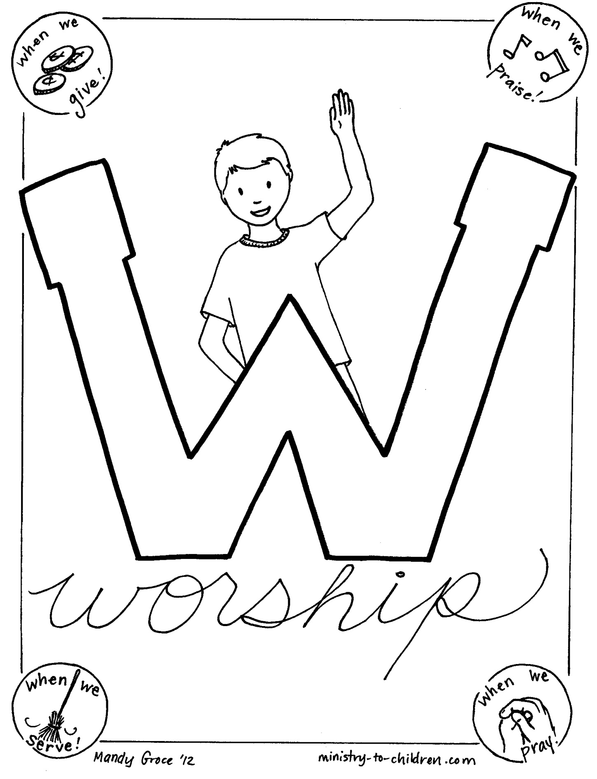
Colouring Page 1

Colouring Page 2

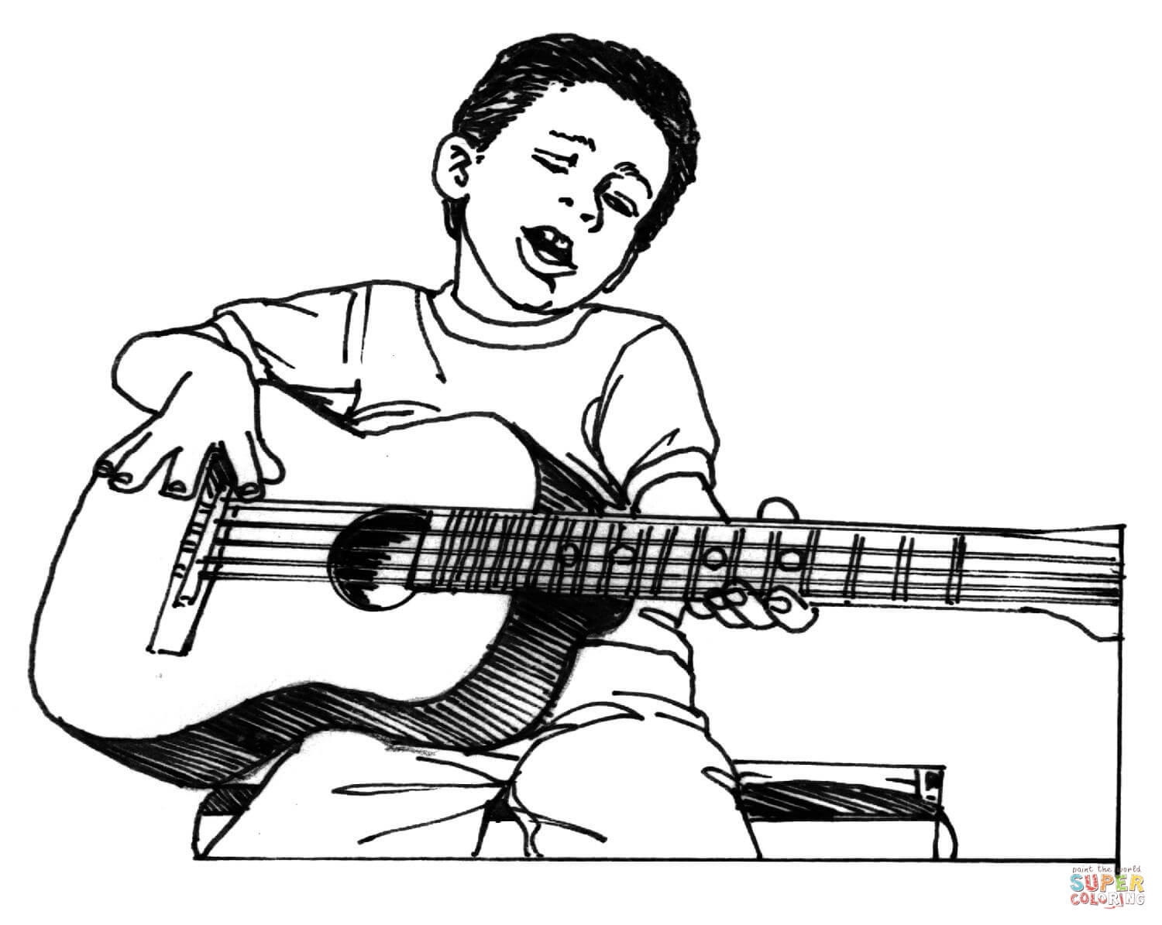
In what two ways is the boy in the picture worshipping God?
- _______________________________________________________________________

- _______________________________________________________________________

Jesus Loves Me

Jesus loves me, this I know For the Bible tells me so Little ones to Him belong They are weak, but He is strong
Yes, Jesus loves me Yes, Jesus loves me Yes, Jesus loves me The Bible tells me so
Cristo me ama, bien lo se Su palabra me hace ver Que los ninos son de aquel Quien es nuestro amigo fiel
Si, Cristo me ama Si, Cristo me ama Si, Cristo me ama La Biblia dice asi
Yes, Jesus loves me Yes, Jesus loves me Yes, Jesus loves me The Bible tells me so

God is so Good

God is so good,
God is so good,
God is so good,
He’s so good to me!

God answers prayer,
God answers prayer,
God answers prayer,
He’s so good to me!

He cares for me,
He cares for me,
He cares for me,
He’s so good to me!

I love Him so,
I love Him so,
I love Him so,
He’s so good to me!

I’ll do His will,
I’ll do His will,
I’ll do His will,
He’s so good to me!

I praise His name,
I praise His name,
I praise His name,
He’s so good to me!
Velna A. Ledin

WITNESS
READING FOR THE DAY:
Acts 1:8
But you will receive power when the Holy Spirit has come upon you; and you will be my witnesses in Jerusalem, in all Judea and Samaria, and to the ends of the earth.”

9:00 – 9:15 a.m. Welcome and Registration
9:15 – 10:00 a.m. Devotions
ETS - Engaging the Scriptures
        - (Use story format or suitable props)
        - (discussion of scripture with application to life)
        - Theme Song & VBS Hymn
        - Prayer

SING-A-LONG: Song suggestions:
- I will make you fishers of men
- I Pledge to Follow You & Hymn: Train Up the Child
- Stop and let me tell you what the Lord has done for me – Marvia Providence

10:15 – 10:30 a.m. BREAK

10:30 – 11:00 a.m. ART AND CRAFT
- PRAYING HANDS: Give children pencils and crayons to trace their own hands on a piece of construction paper and cut out and tape or glue to another piece of paper.
- Have children do the maze: “Prayer helps us get to Jesus who equips and inspires us to go and be witness to Him.”

11:15 – 11:30 a.m. EYEWITNESS SNACK: Have a variety snacks in a bag. Each child will reach in the bag and choose a snack, describe it, and tell everything they know about the snack that they picked.

Teacher, please emphasize that that is how confident and willing we are and ought to be when we know Jesus. We must be willing to tell others about Jesus as our Saviour just as we can talk excitedly about what we know about our favorite snack.
OR

Let them colour the Praying hand and write one thing they want to pray to God about.

11:30 – 12:00 p.m. Dance and Movement

12:00 p.m. –1:00 p.m. LUNCH

1:00 – 1:30 p.m. EXTENDED ACTIVITY: STORY TIME
1:30 – 1:45 p.m. Review Game: Bucket of Gold

1:45 - 2:00 p.m. Closing devotion and Dismissal

RESOURCES: Small packets of popcorn for Drama Activity (Popcorn Prayers) Colouring pages
Crayons, pencils, glue, glitter glue, scissors, Copies of Art work and Songs

What You Will Need
Fisherman Gear for leader to wear
Rod and Reel (optional)
Tackle Box
Box filled with:
A Bible
Cross
Paper that says "Good Deeds"
Printed Lord’s Prayer (See Downloads below).
Church Bulletin
A Bridge to God handout (optional) (See Downloads below).
10 Commandments printed out
Preparation

**Leader CAN BE dressed like a fisherman with vest, hat, boots, rod and reel, etc. and carrying a tackle box.

A bag of goodies for children to do the activity “Eyewitness Snack”

WORK
READING FOR THE DAY:
Colossians 3:23-24
Whatever you do, work at it with all your heart, as working for the Lord, not for human masters, since you know that you will receive an inheritance from the Lord as a reward. It is the Lord Christ you are serving.

9:00 – 9:15 a.m. Welcome and Registration
9:15 – 10:00 a.m. Devotions
- ETS - Engaging the Scriptures
- (Use story format or suitable props)
- (discussion of scripture with application to life)
- Theme Song & VBS Hymn
- Prayer

- SING-A-LONG: Song suggestions:
- Theme Song & VBS Hymn
- I am wrap up tied up in Jesus
- I am on the battlefield for my Lord

10:15 – 10:30 a.m. BREAK

10:30 – 10:45 a.m. DRAMA: BAAING SHEEP
The shepherd tries to identify the sheep by their voices. Ask for a volunteer to be the shepherd and blindfold that person. The other children are sheep and roam around the room. Point to one sheep at a time to call out to the shepherd, saying, “Baa, baa.” The shepherd must answer, “Yes, I hear you, ____,” guessing the name of the player making the sound. If the shepherd is wrong, the sheep continue to bleat, one at a time, with the shepherd guessing. If the shepherd guesses correctly, the sheep becomes the next shepherd and play continues

10:45 – 11:15 a.m. SING-A-LONG: Song suggestions:
  - Whisper A Prayer in the Morning
  - Hear my cry O Lord, attend unto my prayers

11:15 – 11:45 a.m. ART AND CRAFT
- DOT-TO-DOT – Have children join the numbered dots to complete the picture. Have them colour the picture for display

11:45 – 12:00 p.m. EXTENDED ACTIVITY
Remind children that God tends to others or comforts others through other persons. Have the children put small cookies in a small plastic bag and tie it shut with a narrow ribbon. Put the bag, along with a small drink on the napkins or gift paper then tie it to make a gift. Insert it into the mug. Write a person’s name
on a small square of card stock. Punch a hole in the tag and tie it to one end
of the ribbon on the bag. Have children exchange their gift with others.

12:00 p.m. –1:00 p.m. LUNCH
1:00 – 1:30 p.m. Dance and Movement
1:30 – 1:45 p.m. Review Game: Bucket of Gold

1:45 - 2:00 p.m. Closing devotion and Dismissal

RESOURCES: Small plastic bags, ribbon, square, paper to make small nametags, pens crayons, napkins/gift paper, cups or Bashco mugs, cookies, Coloring pages

WELCOME
READING FOR THE DAY:
Hebrews 13:1-2:
Let mutual love continue. ²Do not neglect to show hospitality to strangers, for by doing that some have entertained angels without knowing it.

9:00 – 9:30 a.m. Welcome and Registration
9:15 – 10:00 a.m. Devotions
- ETS - Engaging the Scriptures
- Reading of the Scripture (Use story format or suitable props)
(discussion of scripture reading and application to life)
- Introduction to Theme Song & VBS Hymn
- Prayer

- SING-A-LONG: Song suggestions:
- Intentional Discipleship Theme Song & VBS Hymn
  - Jesus loves me this I know
  - God is so Good
  - Stand up and tell me if you love my Jesus

10:15 – 10:30 a.m. BREAK

10:30 – 11:00 a.m. EXTENDED ACTIVITY:
Draw a picture of yourself welcoming someone in your home.
OR
Colour picture of persons showing hospitality

11:00 – 11:15 a.m. WORSHIP with ART & CRAFT: CLOUD AND DOVE ART:
Allow the children to draw a cloud and add tufts of cotton and pictures or stickers of doves. Write “I saw the Spirit come down from heaven as a dove and remain on him.” John 1:32 on the cloud or around the edges of the poster.

11:30 – 12:00 p.m. DRAMA:

12:00 p.m. –1:00 p.m. LUNCH
1:00 – 1:30 p.m. Dance and Movement
1:30 – 1:45 p.m. Review Game: Bucket of Gold

1:45 - 2:00 p.m. Closing devotion, Prayer Circle and Dismissal

RESOURCES: A CD player to play the different pieces of music
Crayons
Copies of colouring pages

Colouring Page 1

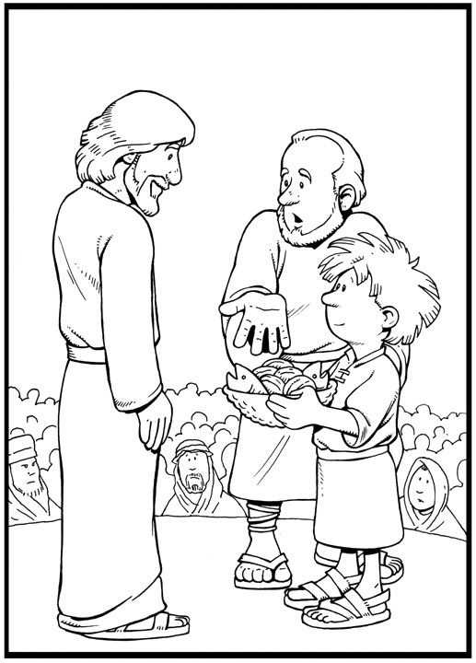

STORYTIME Today we are going fishing. I’ve got my boots, my hat, my rod and reel. What else do I need? (Tackle Box). What kinds of things would you have in your tackle box? Open tackle box and pull out items like hooks, bobbers, fake bait, lures, etc. Did you know that God wants us to be fishermen? Let’s see what the Bible has to say. As Jesus walked beside the Sea of Galilee, he saw Simon and his brother Andrew casting a net into the lake, for they were fishermen. "Come, follow me," Jesus said, "and I will make you fishers of men." At once they left their nets and followed him. Mark 1:16-18. So, what kind of fishermen did Jesus want Simon and Andrew to be? (Fishers of men). What does that mean? (Discuss the meaning of bringing others to Christ). As Christians, what kind of fishermen does God want us to be? (Fishers of men). If we were going to put together a tackle box to be fishers of men, what kinds of things would we need in it? Bible, Cross, "Good Deeds", Lord’s Prayer, Church Bulletin. How can we use these tools to be better fishermen? Pull out the Bible. (Read it to better know what God wants us to do, read it to others). Cross: (Wear it so others will know we are Christians. Use it to explain how Jesus died for our sins). Good Deeds: (Use these to show how Christians act). Lord’s Prayer: (Pray to God for guidance. Show others how to pray). Church Bulletin: (Pray for people on the prayer list. Tell others about upcoming events). A Bridge To God Handout - explain how Christ is the only path to God. Ten Commandments (Talk to people about how God wants us to behave.)

